

CSE 1004

Network and Communication

LAB ASSESSMENT - 3

**NAME**: Vibhu Kumar Singh

**REG. NO**: 19BCE0215

**TEACHER**: Santhi H.

**1. Write a menu driven code for Decimal, Binary**

1. **To check the class, network id and host id of an IPv4 address. (Use function wherever necessary)**
2. **To check whether given IP address is valid or not.**
3. **To find first address, last address and number of addresses in the block.**

**Ans 1)**

**Aim:** To check for Validity, Class, Network ID, Host ID, First Address,

Last Address and Number of Addresses of a user input IPv4 Address (classful).

**Algorithms:**

* Validity:

Each Byte of an IPv4 Address must be between 0 and 255

(0-11111111 if binary) and there should be exactly 4 such bytes.

* Class:

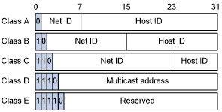

**Class A :** First Byte must be between 0 and 127 or start with 0 if binary input.

**Class B :** First Byte must be between 128 and 191 or start with 10 if binary input.

**Class C :** First Byte must be between 192 and 223 or start with 110 if binary input.

**Class D :** First Byte must be between 224 and 239 or start with 1110 if binary input.

**Class E :** First Byte must be between 240 and 255 or start with 11111 if binary input.

* Network ID/Host ID:

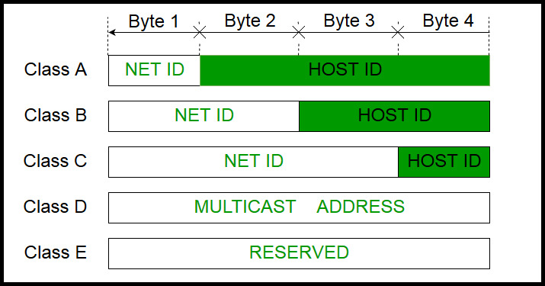

Class A : First Byte is the Network ID, rest is Host ID.

Class B : First and Second is Network ID, rest is Host ID.

Class C : First, second and third bytes is Network ID, rest is Host

ID.

Class D : Multicast Addresses.

Class E : Reserved Addresses.

* First/Last Addresses:

Class A : First Address is 0.0.0.0

Last Address is 127.255.255.255

Class B : First Address is 128.0.0.0

Last Address is 191.255.255.255

Class C : First Address is 192.0.0.0

Last Address is 223.255.255.255

Class D : Invalid as there is no subnet.

Class E : Invalid as there is no subnet.

**Menu-Driven Source Code:**

#include<bits/stdc++.h>

using **namespace** std;

**int** DecimalOrBinary();

**void** DecimalIPClass();

**bool** ValidIP(string,**int**);

**void** DecimalFirstLast();

**void** BinaryIPClass();

**int** toDecimal(string);

**void** BinaryFirstLast();

**void** IPClassMenu()

{

**int** decimalBinary=DecimalOrBinary();

    switch(decimalBinary)

    {

        case 1:

            DecimalIPClass();

            break;

        case 2:

            BinaryIPClass();

            break;

    }

    cout<<"\n-----------------------------------------\n\n\n";

}

**void** DecimalIPClass()

{

    start:

    string ip;

    cout<<"Enter the Decimal IP Address: ";

    cin>>ip;

    if(ValidIP(ip,1))

    {

        string block1="";

        string block2="";

        string block3="";

        string block4="";

**int** i=0;

        while(ip[i]!='.')

        {

            block1.push_back(ip[i]);

            i++;

        }

        i++;

        while(ip[i]!='.')

        {

            block2.push_back(ip[i]);

            i++;

        }

        i++;

        while(ip[i]!='.')

        {

            block3.push_back(ip[i]);

            i++;

        }

        i++;

        while(ip[i])

        {

            block4.push_back(ip[i]);

            i++;

        }

        if(stoi(block1)<=127)

        {

            cout<<"\nClass: Class A\nNetwork ID: "<<block1<<"\nHost ID: "<<block2<<"."<<block3<<"."<<block4;

        }

        else if(stoi(block1)>=128 && stoi(block1)<=191)

        {

            cout<<"\nClass: Class B\nNetwork ID: "<<block1<<"."<<block2<<"\nHost ID: "<<block3<<"."<<block4;

        }

        else if(stoi(block1)>=192 && stoi(block1)<=223)

        {

            cout<<"\nClass: Class C\nNetwork ID: "<<block1<<"."<<block2<<"."<<block3<<"\nHost ID: "<<block4;

        }

        else if(stoi(block1)>=224 && stoi(block1)<=239)

        {

            cout<<"\nClass: Class D";

        }

        else

        {

            cout<<"\nClass: Class E";

        }

    }

    else

    {

        cout<<"\nEnter a valid IP Address.\n";

        goto start;

    }

}

**void** BinaryIPClass()

{

    start:

    string ip;

    cout<<"Enter the Binary IP Address: ";

    cin>>ip;

    if(ValidIP(ip,2))

    {

        string block1="";

        string block2="";

        string block3="";

        string block4="";

**int** i=0;

        while(ip[i]!='.')

        {

            block1.push_back(ip[i]);

            i++;

        }

        i++;

        while(ip[i]!='.')

        {

            block2.push_back(ip[i]);

            i++;

        }

        i++;

        while(ip[i]!='.')

        {

            block3.push_back(ip[i]);

            i++;

        }

        i++;

        while(ip[i])

        {

            block4.push_back(ip[i]);

            i++;

        }

        if(toDecimal(block1)<=127)

        {

            cout<<"\nClass: Class A\nNetwork ID: "<<block1<<"\nHost ID: "<<block2<<"."<<block3<<"."<<block4;

        }

        else if(toDecimal(block1)>=128 && toDecimal(block1)<=191)

        {

            cout<<"\nClass: Class B\nNetwork ID: "<<block1<<"."<<block2<<"\nHost ID: "<<block3<<"."<<block4;

        }

        else if(toDecimal(block1)>=192 && toDecimal(block1)<=223)

        {

            cout<<"\nClass: Class C\nNetwork ID: "<<block1<<"."<<block2<<"."<<block3<<"\nHost ID: "<<block4;

        }

        else if(toDecimal(block1)>=224 && toDecimal(block1)<=239)

        {

            cout<<"\nClass: Class D is for Multicast Addresses";

        }

        else

        {

            cout<<"\nClass: Class E is for  Reserved Addresses";

        }

    }

    else

    {

        cout<<"\nEnter a valid IP Address.\n";

        goto start;

    }

}

**int** toDecimal(string s)

{

    return stoi(s,0,2);

}

**bool** ValidIP(string ip, **int** decimalBinary)

{

**int** j=0;

**int** dots=0;

    while(ip[j])

    {

        if(!isdigit(ip[j]) && ip[j]!='.')

            return false;

        if(ip[j]=='.')

            dots++;

        j++;

    }

    string block1="";

    string block2="";

    string block3="";

    string block4="";

**int** i=0;

    while(ip[i]!='.' && i<ip.length())

    {

        block1.push_back(ip[i]);

        i++;

    }

    i++;

    while(ip[i]!='.' && i<ip.length())

    {

        block2.push_back(ip[i]);

        i++;

    }

    i++;

    while(ip[i]!='.' && i<ip.length())

    {

        block3.push_back(ip[i]);

        i++;

    }

    i++;

    while(ip[i])

    {

        block4.push_back(ip[i]);

        i++;

    }

**int** flag=0;

    if(decimalBinary==1)

    {

        if(dots==3 && !block1.empty() && !block2.empty() && !block3.empty() && !block4.empty())

        {

            if(stoi(block1)>=0 && stoi(block1)<=255)

            {

                if(stoi(block2)>=0 && stoi(block2)<=255)

                {

                    if(stoi(block3)>=0 && stoi(block3)<=255)

                    {

                        if(stoi(block4)>=0 && stoi(block4)<=255)

                        {

                            flag=1;

                            return true;

                        }

                    }

                }

            }

        }

        if(flag==0)

        {

            return false;

        }

    }

    else if(decimalBinary==2)

    {

**int** k=0;

        while(ip[k])

        {

            if(ip[k]!='1' && ip[k]!='0' && ip[k]!='.')

            {

                return false;

            }

            k++;

        }

        if(dots==3 && !block1.empty() && !block2.empty() && !block3.empty() && !block4.empty())

        {

            if(toDecimal(block1)>=0 && toDecimal(block1)<=255)

            {

                if(toDecimal(block2)>=0 && toDecimal(block2)<=255)

                {

                    if(toDecimal(block3)>=0 && toDecimal(block3)<=255)

                    {

                        if(toDecimal(block4)>=0 && toDecimal(block4)<=255)

                        {

                            return true;

                        }

                    }

                }

            }

        }

        else

        {

            return false;

        }

    }

}

**int** DecimalOrBinary()

{

    start:

**int** choice;

    cout<<"1.Decimal\n2.Binary\nEnter your choice: ";

    cin>>choice;

    cout<<"--------------------------------------------\n\n";

    switch(choice)

    {

        case 1:

            return 1;

        case 2:

            return 2;

        default:

            cout<<"\nInvalid Choice\n";

            goto start;

    }

}

**void** ValidIPMenu()

{

**int** decimalBinary=DecimalOrBinary();

    if(decimalBinary==1)

    {

        cout<<"Enter Decimal IP Address: ";

    }

    if(decimalBinary==2)

    {

        cout<<"Enter Binary IP Address: ";

    }

    string ip;

    cin>>ip;

**bool** isvalid=ValidIP(ip,decimalBinary);

    if(isvalid)

    {

        cout<<"\nThe input IP Address is VALID.\n";

    }

    else

    {

        cout<<"\nThe input IP Address is INVALID\n";

    }

    cout<<"\n-----------------------------------------\n\n\n";

}

**void** FirstLastMenu()

{

**int** decimalBinary=DecimalOrBinary();

    switch(decimalBinary)

    {

        case 1:

            DecimalFirstLast();

            break;

        case 2:

            BinaryFirstLast();

            break;

    }

    cout<<"\n--------------------------------------\n\n\n";

}

**void** DecimalFirstLast()

{

    start:

    string ip;

    cout<<"\nEnter the Decimal IP Address: ";

    cin>>ip;

    if(ValidIP(ip,1))

    {

        string block1="";

        string block2="";

        string block3="";

        string block4="";

**int** i=0;

        while(ip[i]!='.')

        {

            block1.push_back(ip[i]);

            i++;

        }

        i++;

        while(ip[i]!='.')

        {

            block2.push_back(ip[i]);

            i++;

        }

        i++;

        while(ip[i]!='.')

        {

            block3.push_back(ip[i]);

            i++;

        }

        i++;

        while(ip[i])

        {

            block4.push_back(ip[i]);

            i++;

        }

        if(stoi(block1)<=127)

        {

            cout<<"First Address: "<<block1<<".0.0.0\nLast Address: "<<block1<<".255.255.255\nNumber of Addresses: "<<(**long** **long** **int**)pow(2,24);

        }

        else if(stoi(block1)>=128 && stoi(block1)<=191)

        {

            cout<<"First Address: "<<block1<<"."<<block2<<".0.0\nLast Address: "<<block1<<".255.255\nNumber of Addresses: "<<(**long** **long** **int**)pow(2,16);

        }

        else if(stoi(block1)>=192 && stoi(block1)<=223)

        {

            cout<<"First Address: "<<block1<<"."<<block2<<block3<<".0\nLast Address: "<<block1<<".255\nNumber of Addresses: "<<pow(2,8);

        }

        else if(stoi(block1)>=224 && stoi(block1)<=239)

        {

            cout<<"First Address: Invalid\nLast Address: Invalid\nNumber of Addresses: Invalid";

        }

        else if(stoi(block1)>=240 && stoi(block1)<=255)

        {

            cout<<"First Address: Invalid\nLast Address: Invalid\nNumber of Addresses: Invalid";

        }

    }

    else

    {

        cout<<"\nEnter a valid IP Address.\n";

        goto start;

    }

}

**void** BinaryFirstLast()

{

    start:

    string ip;

    cout<<"\nEnter the Decimal IP Address: ";

    cin>>ip;

    if(ValidIP(ip,2))

    {

        string block1="";

        string block2="";

        string block3="";

        string block4="";

**int** i=0;

        while(ip[i]!='.')

        {

            block1.push_back(ip[i]);

            i++;

        }

        i++;

        while(ip[i]!='.')

        {

            block2.push_back(ip[i]);

            i++;

        }

        i++;

        while(ip[i]!='.')

        {

            block3.push_back(ip[i]);

            i++;

        }

        i++;

        while(ip[i])

        {

            block4.push_back(ip[i]);

            i++;

        }

        if(toDecimal(block1)<=127)

        {

            cout<<"First Address: "<<block1<<".0.0.0\nLast Address: "<<block1<<".11111111.11111111.11111111\nNumber of Addresses: "<<(**long** **long** **int**)pow(2,24);

        }

        else if(toDecimal(block1)>=128 && toDecimal(block1)<=191)

        {

            cout<<"First Address: "<<block1<<"."<<block2<<".0.0\nLast Address: "<<block1<<".11111111.11111111\nNumber of Addresses: "<<(**long** **long** **int**)pow(2,16);

        }

        else if(toDecimal(block1)>=192 && toDecimal(block1)<=223)

        {

            cout<<"First Address: "<<block1<<"."<<block2<<block3<<".0\nLast Address: "<<block1<<".11111111\nNumber of Addresses: "<<pow(2,8);

        }

        else if(toDecimal(block1)>=224 && toDecimal(block1)<=239)

        {

            cout<<"First Address: Invalid\nLast Address: Invalid\nNumber of Addresses: Invalid";

        }

        else

        {

            cout<<"First Address: Invalid\nLast Address: Invalid\nNumber of Addresses: Invalid";

        }

    }

    else

    {

        cout<<"\nEnter a valid IP Address.";

        goto start;

    }

}

**void** options()

{

    while(true)

    {

cout<<"---------IPv4 Addressing Main Menu--------\n          by [VIBHU KUMAR SINGH]\n\n";

        cout<<"1.To check the class, network id and host id of an IPv4 address\n2.To check whether given IP address is valid or not\n3.To find first address, last address and number of addresses in the block\n0. Exit\nEnter your choice: ";

**int** choice;

        cin>>choice;

        cout<<"----------------------------------------------------------------------------\n\n";

        switch(choice)

        {

            case 1:

                IPClassMenu();

                break;

            case 2:

                ValidIPMenu();

                break;

            case 3:

                FirstLastMenu();

                break;

            case 0:

                exit(0);

                break;

            default:

                cout<<"\nInvalid Choice\n";

                break;

        }

    }

}

**int** main()

{

    system("cls");

    options();

    return 0;

}

**OUTPUT SCREENSHOTS:**

1. **To check the class, network id and host id of an IPv4 address :**
2. **Decimal IP:**

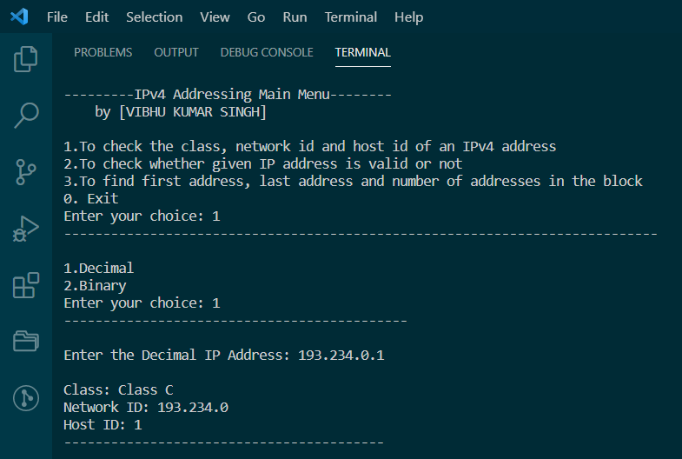

1. **Binary IP:**

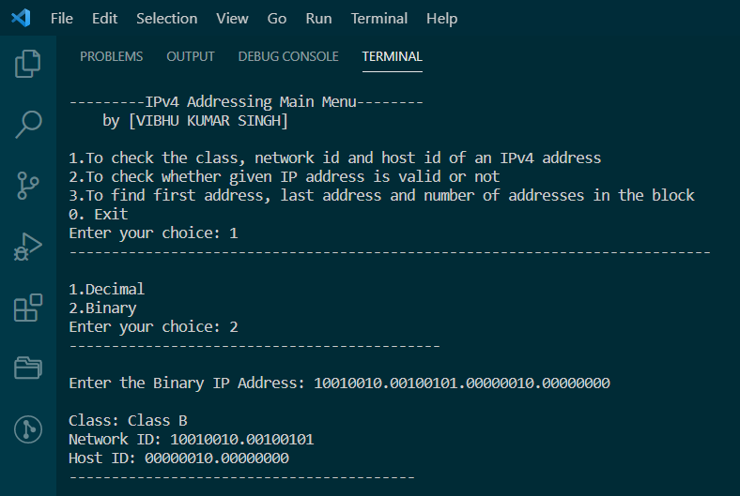

1. **To check whether given IP address is valid or not :**
2. **Decimal IP:**

* **Invalid:**

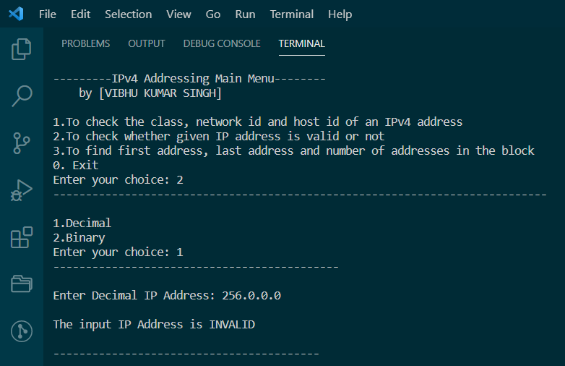

**(Invalid because first byte is greater than 255)**

* **Valid:**

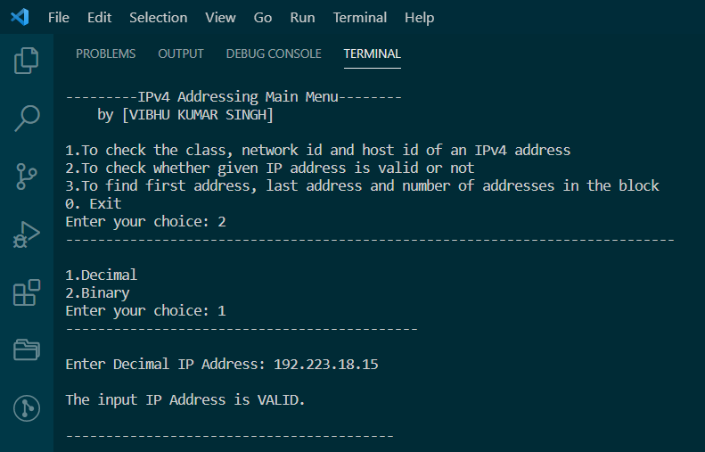

1. **Binary IP:**

* **Invalid:**

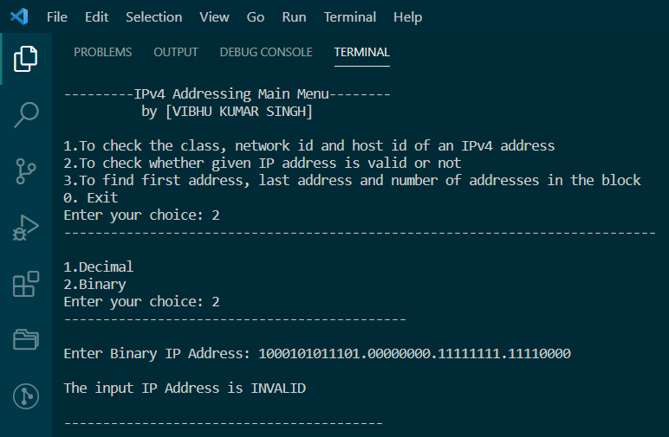

**(invalid because first byte is greater than 8 bits)**

* **Valid:**

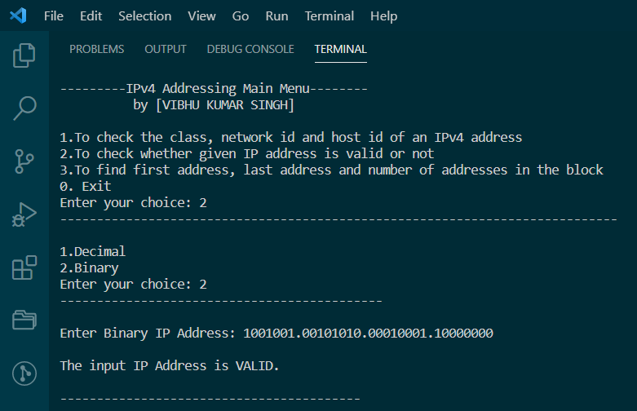

1. **To find first address, last address and number of addresses in the block :**
2. **Decimal IP:**

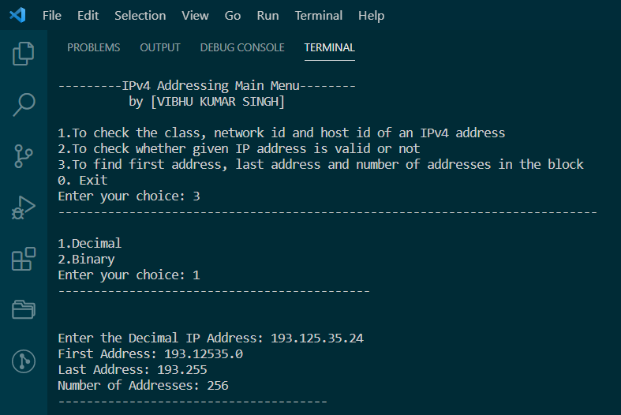

1. **Binary IP:**

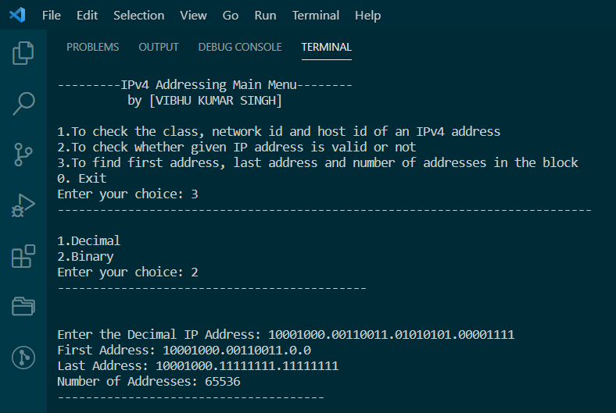

**2. Implement the following unicast routing algorithms using functions.**

* 1. **Distance Vector Routing**
  2. **Link State Routing**

**Ans 2)**

**Aim:** To implement Distance Vector and Link State Routing Techniques

in C++.

**Algorithms:**

1. **Distance Vector Routing:**

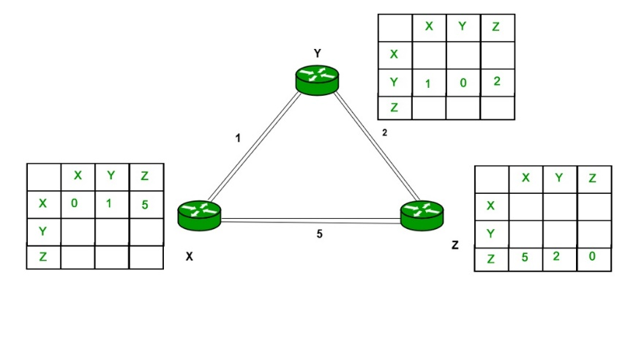

1. A router transmits its distance vector to each of its neighbours in a routing packet.
2. Each router receives and saves the most recently received distance vector from each of its neighbours.
3. A router recalculates its distance vector when:
   * It receives a distance vector from a neighbour containing different information than before.
   * It discovers that a link to a neighbour has gone down.
4. **Link State Routing:**

* **Step-1:** The node is taken and chosen as a root node of the tree, this creates the tree with a single node, and now set the total cost of each node to some value based on the information in Link State Database
* **Step-2:** Now the node selects one node, among all the nodes not in the tree like structure, which is nearest to the root, and adds this to the tree. The shape of the tree gets changed .
* **Step-3:** After this node is added to the tree, the cost of all the nodes not in the tree needs to be updated because the paths may have been changed.
* **Step-4:** The node repeats the Step 2. and Step 3. until all the nodes are added in the tree

**Menu-Driven Source Code:**

#include<bits/stdc++.h>

#define INF -1

#define MAX 10

using **namespace** std;

**void** LinkState();

**void** DistanceVector();

**void** DistanceVector()

{

**int** graph[50][50];

**int** i,j,k,t;

**int** nn;

    cout<<"\n Enter Number of Nodes:";

    cin>>nn;

    for (i=0;i<nn;i++)

    {

        for(j=0;j<nn;j++)

        {

            graph[i][j]=-1;

        }

    }

**char** ch[7]={'A','B','C','D','E','F','G'};

    for (i=0;i<nn;i++)

    {

        for(j=0;j<nn;j++)

        {

            if(i==j)

            {

                graph[i][j]=0;

            }

            if(graph[i][j]==-1)

            {

                cout<<"\n Enter Distance between "<<ch[i]<<" - "<<ch[j]<<" : ";

                cin>>t;

                graph[i][j]=graph[j][i]=t;

            }

        }

    }

**int** via[50][50];

    for (i=0;i<nn;i++)

    {

        for(j=0;j<nn;j++)

        {

            via[i][j]=-1;

        }

    }

    cout<<"\n After Initialization";

    for (i=0;i<nn;i++)

    {

        cout<<"\n"<<ch[i]<<" Table";

        cout<<"\nNode\tDist\tVia";

        for(j=0;j<nn;j++)

        {

            cout<<"\n"<<ch[j]<<"\t"<<graph[i][j]<<"\t"<<via[i][j];

        }

    }

**int** sh[50][50][50];

    for(i=0;i<nn;i++)

    {

        for(j=0;j<nn;j++)

        {

            for (k=0;k<nn;k++)

            {

                if((graph[i][j]>-1)&&(graph[j][k]>-1))

                {

                    sh[i][j][k]=graph[j][k]+graph[i][j];

                }

                else

                {

                    sh[i][j][k]=-1;

                }

            }

        }

    }

    for(i=0;i<nn;i++)

    {

        cout<<"\n\n For "<<ch[i];

        for (j=0;j<nn;j++)

        {

            cout<<"\n From "<<ch[j];

            for(k=0;k<nn;k++)

            {

                cout<<"\n "<<ch[k]<<" "<<sh[i][j][k];

            }

        }

    }

**int** final[50][50];

    for(i=0;i<nn;i++)

    {

        for(j=0;j<nn;j++)

        {

            final[i][j]=graph[i][j];

            via[i][j]=i;

            for(k=0;k<nn;k++)

            {

                if((final[i][j]>sh[i][k][j]) || (final[i][j] == -1))

                {

                    if(sh[i][k][j]>-1)

                    {

                        final[i][j]=sh[i][k][j];

                        via[i][j]=k;

                    }

                }

            }

            if(final[i][j]==-1)

            {

                for(k=0;k<nn;k++)

                {

                    if((final[i][k]!=-1)&&(final[k][j]!=-1))

                    {

                        if((final[i][j]==-1) || ((final[i][j]!=-1) &&(final[i][j]>final[i][k]+final[k][j])))

                        {

                            if(final[i][k]+final[k][j]>-1)

                            {

                                final[i][j]=final[i][k]+final[k][j];

                                via[i][j]=k;

                            }

                        }

                    }

                }

            }

        }

    }

    cout<<"\n After Update :";

    for (i=0;i<nn;i++)

    {

        cout<<"\n"<<ch[i]<<" Table";

        cout<<"\nNode\tDist\tVia";

        for(j=0;j<nn;j++)

        {

            cout<<"\n"<<ch[j]<<"\t"<<final[i][j]<<"\t";

            if(i==via[i][j])

                cout<<"-";

            else

                cout<<ch[via[i][j]];

        }

    }

    cout<<"\n\n-----------------------------\n\n";

}

**void** dijkstra(**int** G[MAX][MAX],**int** n,**int** startnode)

{

**int** cost[MAX][MAX],distance[MAX],pred[MAX];

**int** visited[MAX],count,mindistance,nextnode,i,j;

    for(i=0;i<n;i++)

        for(j=0;j<n;j++)

            if(G[i][j]==0)

                cost[i][j]=INF;

            else

                cost[i][j]=G[i][j];

    for(i=0;i<n;i++)

    {

        distance[i]=cost[startnode][i];

        pred[i]=startnode;

        visited[i]=0;

    }

    distance[startnode]=0;

    visited[startnode]=1;

    count=1;

    while(count<n-1)

    {

        mindistance=INF;

        for(i=0;i<n;i++)

            if(distance[i]<mindistance&&!visited[i])

            {

                mindistance=distance[i];

                nextnode=i;

            }

        visited[nextnode]=1;

        for(i=0;i<n;i++)

            if(!visited[i])

                if(mindistance+cost[nextnode][i]<distance[i])

                {

                    distance[i]=mindistance+cost[nextnode][i];

                    pred[i]=nextnode;

                }

        count++;

    }

    for(i=0;i<n;i++)

        if(i!=startnode)

        {

            if(distance[i]!=-1)

            {

                cout<<"\nDistance of the node "<<i<<" = "<<distance[i];

                cout<<"\nPath = "<<i;

                j=i;

                do

                {

                    j=pred[j];

                    cout<<"<-"<<j;

                }while(j!=startnode);

                cout<<"\n";

            }

            else

            {

                cout<<"\nDistance of the node "<<i<<" = INF";;

                cout<<"\nNo path";

            }

        }

        cout<<"\n-----------------------------\n\n";

}

**void** LinkState()

{

**int** G[MAX][MAX],i,j,n,u;

    cout<<"Enter the number of vertices: ";

    cin>>n;

    cout<<"\nEnter the adjacency matrix:\n";

    for(i=0;i<n;i++)

        for(j=0;j<n;j++)

            cin>>G[i][j];

    while(true)

    {

        cout<<"\nEnter the source/start node: ";

        cin>>u;

        dijkstra(G,n,u);

    }

}

**int** main()

{

system("cls");

    while(true)

    {

cout<<"---------Unicast Routing Main Menu--------\n          by [VIBHU KUMAR SINGH]\n\n";

        cout<<"1.Distance Vector Routing\n2.Link State Routing\n0. Exit\nEnter your choice: ";

**int** choice;

        cin>>choice;

        cout<<"----------------------------------------------------------------------------\n\n";

        switch(choice)

        {

            case 1:

                DistanceVector();

                break;

            case 2:

                LinkState();

                break;

            case 0:

                exit(0);

                break;

            default:

                cout<<"\nInvalid Choice\n";

                break;

        }

    }

}

**OUTPUT SCREENSHOTS:**

1. **Distance Vector Routing:**

Input Graph:

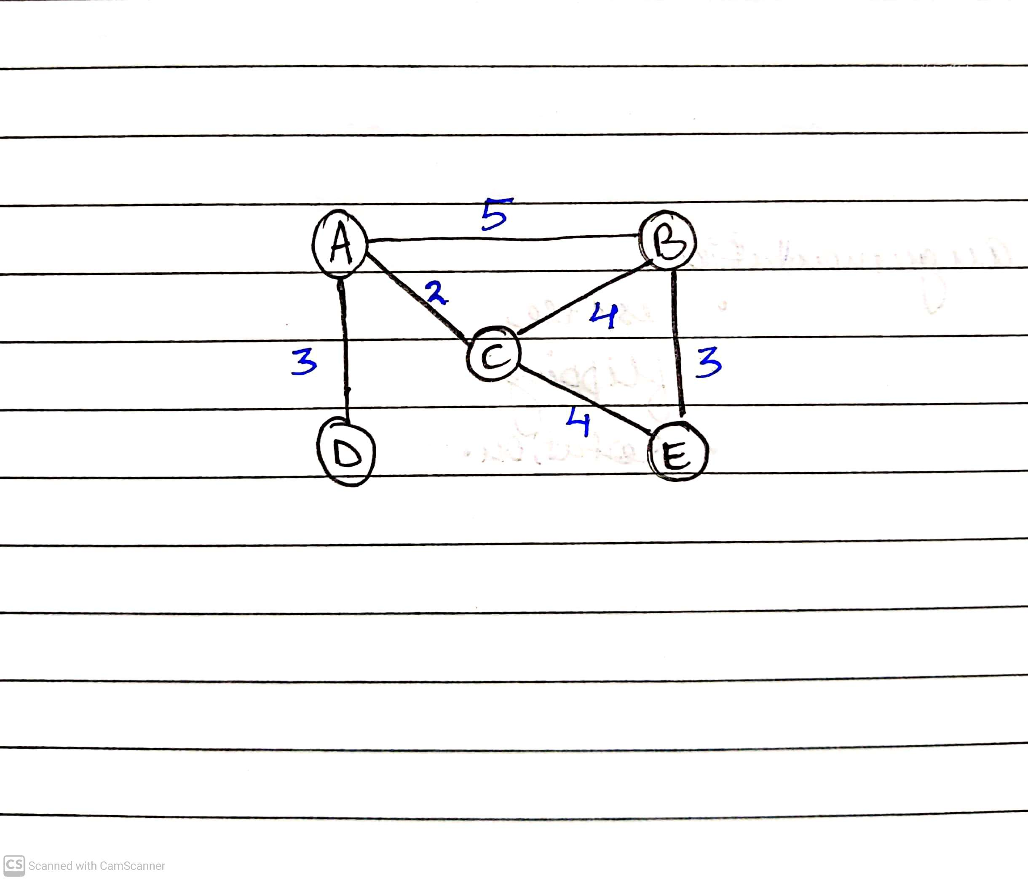

Inputting:

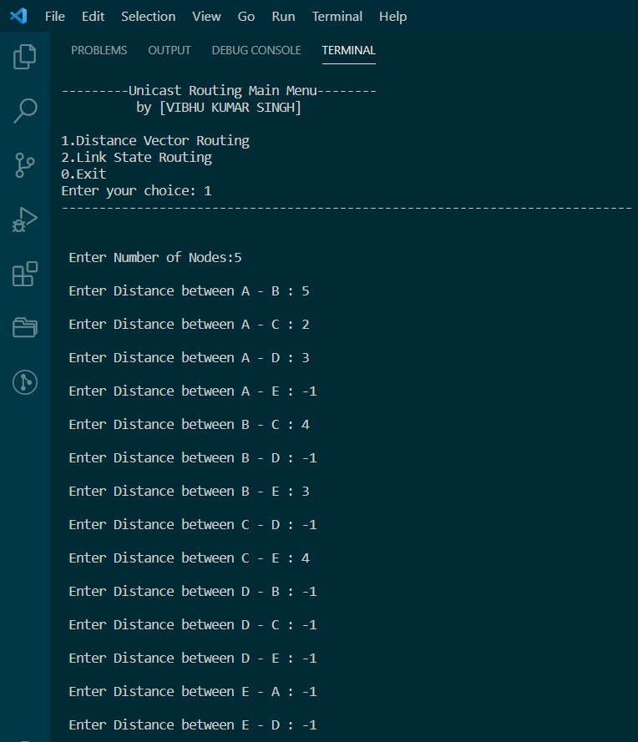

After Initialization:

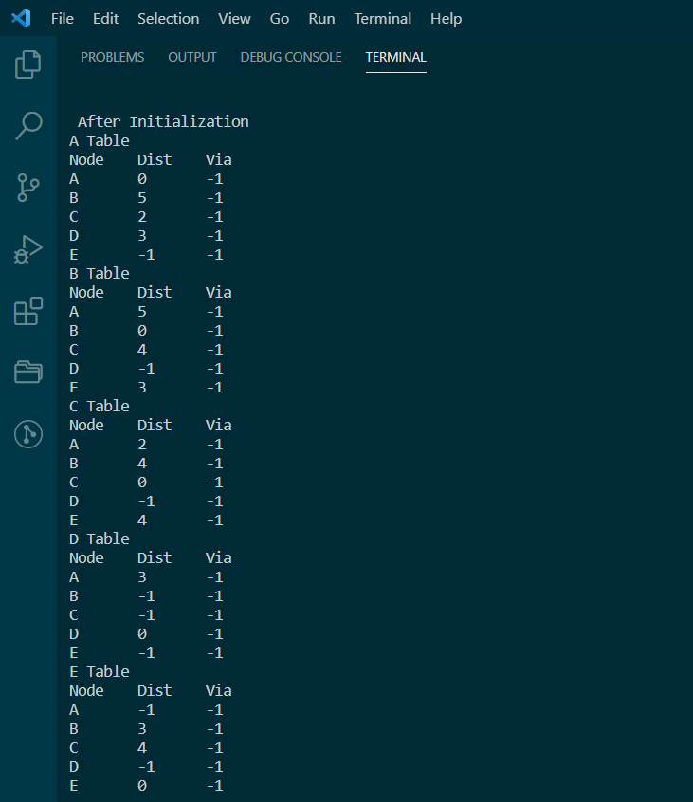

After Updating:

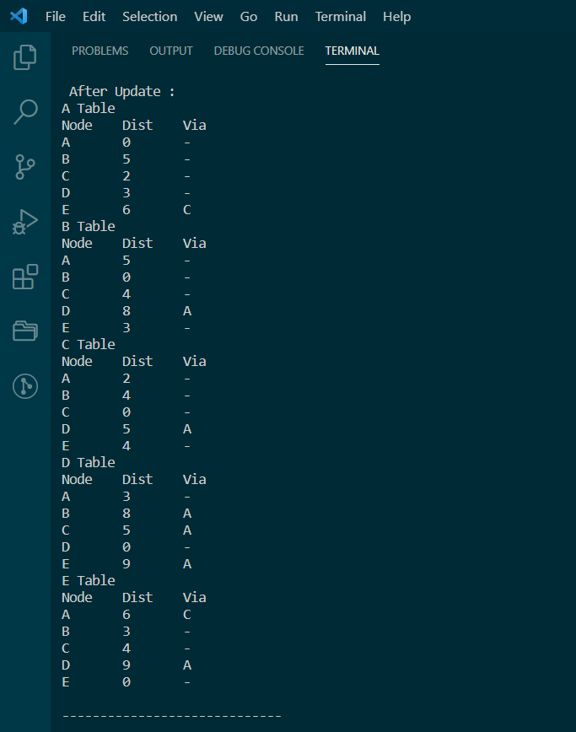

1. **Link State Routing:**

Input Graph:

